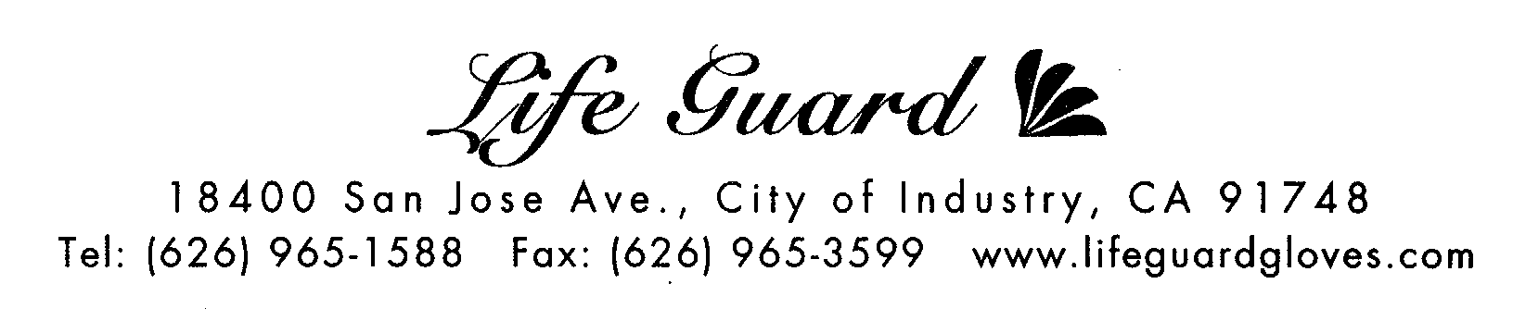

MATERIAL SAFETY DATA SHEET

ITEM NUMBER 2390
BRAND NAME: Sanitex
PRODUCT NAME: VINYL POWDER FREE GLOVE, NON-MEDICAL
FOR INDUSTRIAL USE ONLY
TRADE NAME: “Sanitex” brand VINYL GENERAL PURPOSE GLOVES
MAIN MATERIAL: Poly Vinyl Chloride ( PVC)
FDA 510(K) NO: NOT REQUIRED
REGISTRATION NO: NOT REQUIRED
D.O.T. RATING: NOT RESTRICTED
SAMPLING PLAN S-4, AQL ABOUT 2.5

Sanitex Gloves are first grade gloves freshly manufactured on the same production line that medical gloves are made but without going through the rigorous FDA medical inspection. We do not use rejects or 2nds. Gloves are made with ingredients in compliance with 21CFR as accepted by the USDA for use in food processing industry.

SPECIFICATION
SIZE /ITEM # | Small(2392) | Medium(2393) | Large(2394) | X-Large(2395)
Length (mm) | 230 | 235 | 240 | 240
Width at Palm (mm) | 85±5 | 95±5 | 105±5 | 115±5
THICKNESS AT PALM mm (mil) | 0.08 (3.1 mil) | 0.08 (3.1 mil) | 0.08 (3.1 mil) | 0.08 (3.1 mil)
THICKNESS AT FINGER mm (mil) | 0.09 (3.5 mil) | 0.08 (3.1mil) | 0.09 (3.5mil) | 0.09 (3.5mil)

PROPERTIES
 | BEFORE AGING
TENSILE STRENGTH | 11 MPa
ULTIMATE ELONGATION | 300 %
ORIENTATION | Ambidextrous
CUFF | Rounded Bead
COLOR | Natural White

FIRE AND EXPLOSION
STABILITY | FLASH POINT | EXTINGUISHING MEDIA | CONDITION TO AVOID | IMCOMPATIBLE MATERIAL
Stable | N/A | Foam, Water, CO2 | None | None

PACKAGING 100 pieces per dispenser box, 10 boxes / case. 112 cases per pallet..

STORAGE Store at room temperature. Keep away from heat.
Avoid direct sunlight and fluorescent light.

CAUTION Components used in making these gloves may cause allergic reaction to some users and
patients. Discontinue use if reddening or irritations occur. Not intended for use as a
general chemical barrier.

