SDS Number: 68

**Power Kleen Plus**

Revision Date: 11/17/2014

**Page** 1

**of** 9

**1 PRODUCT AND COMPANY IDENTIFICATION**

**Manufacturer**

MSM INC.___________________

1101 E Francisco Blvd San Rafael, CA 94901 ___________

**Contact: Phone: Web:**

Chemical Compounding Company____

510-430-2792____ [________](http://www.chemicalcompounding.com)

**Product Name: Revision Date: Version:**

**SDS Number: Common Name: CAS Number: Product Code: Chemical Family: Chemical Formula:**

Power Kleen Plus

11/17/2014

1

68

Alkaline Cleaner

MIXTURE SM-K2R

Alkaline Cleaner

*** PROPRIETARY ***

**Emergency Phone:** +1-800-424-9300 (Chemtrec)

**2 HAZARDS IDENTIFICATION**

NFPA: HMIS III:

Health = 1, Fire = 0, Reactivity = 0

H*1/F0/PH0

**1**

**0 0**

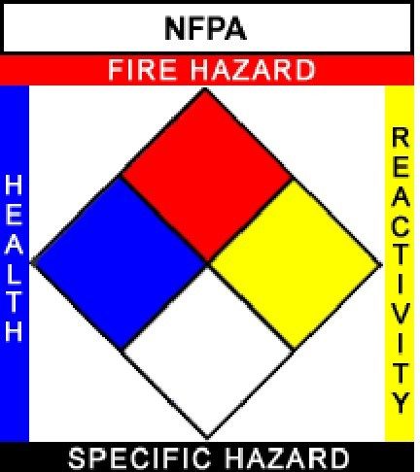

**1 0**

**0**

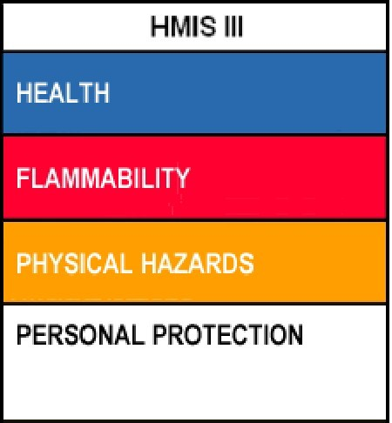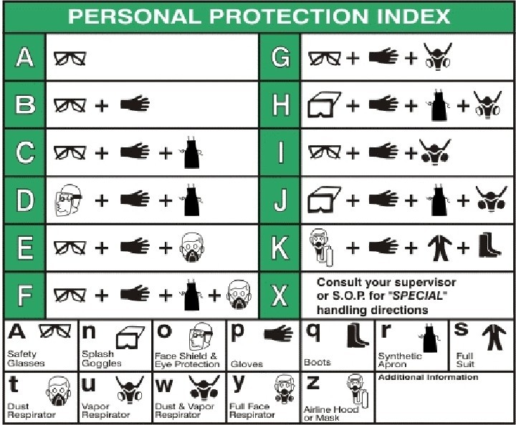

**B | Safety Glasses, Gloves**

GHS Signal Word:

WARNING

GHS Hazard Pictograms:

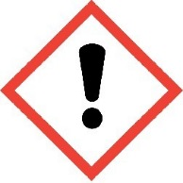

SDS Number: 68

**Power Kleen Plus**

Revision Date: 11/17/2014

GHS Classifications:

Health, Acute toxicity, 4 Oral

Health, Acute toxicity, 4 Dermal

Health, Skin corrosion/irritation, 3

Health, Serious Eye Damage/Eye Irritation, 2 A

Health, Acute toxicity, 5 Inhalation

GHS Phrases:

H302 - Harmful if swallowed

H312 - Harmful in contact with skin

H316 - Causes mild skin irritation

H319 - Causes serious eye irritation

H333 - May be harmful if inhaled

GHS Precautionary Statements:

P210 - Keep away from heat/sparks/open flames/hot surfaces. No smoking

P260 - Do not breathe dust/fume/gas/mist/vapors/spray.

P262 - Do not get in eyes, on skin, or on clothing.

P264 - Wash skin thoroughly after handling.

P270 - Do not eat, drink or smoke when using this product.

P271 - Use only outdoors or in a well-ventilated area.

P273 - Avoid release to the environment.

P280 - Wear protective gloves/protective clothing/eye protection/face protection.

P301+310 - IF SWALLOWED: Immediately call a POISON CENTER or doctor/physician.

P301+330+331 - IF SWALLOWED: Rinse mouth. Do NOT induce vomiting.

**Page** 2

**of** 9

P303+361+353 - IF ON SKIN (or hair): Remove/Take off immediately all contaminated clothing. Rinse skin with water/shower.

P304+341 - IF INHALED: If breathing is difficult, remove victim to fresh air and keep at rest in a position comfortable for breathing.

P305+351+338 - IF IN EYES: Rinse continuously with water for several minutes. Remove contact lenses if present and easy to do. Continue rinsing.

P321 - Specific treatment (see supplemental first aid instructions on this label).

P332+313 - If skin irritation occurs: Get medical advice/attention.

P337 - If eye irritation persists: Get medical advice/attention.

P363 - Wash contaminated clothing before reuse.

P403+233 - Store in a well ventilated place. Keep container tightly closed.

P405 - Store locked up.

P501 - Dispose of contents/container to an approved waste disposal plant.

**3 COMPOSITION/INFORMATION ON INGREDIENTS**

**Ingredients:**

**Cas # | Percentage | Chemical Name**

**-------------------------------------------------------------------------------------------------------**

**111-76-2 | <8% | 2-Butoxyethanol**

**9016-45-9 | <8% | Poly(oxy-1,2-ethanediyl), .alpha.-(nonylphenyl)-.omega.-hydroxy-**

**7758-29-4 | <5% | Triphosphoric acid, pentasodium salt**

**1310-73-2 | <5% | Sodium Hydroxide**

**N/A | >74% | Proprietary, non-hazardous, non-regulated**

SDS Number: 68

**Power Kleen Plus**

Revision Date: 11/17/2014

**4 FIRST AID MEASURES**

**Page** 3

**of** 9

**Inhalation: Skin Contact: Eye Contact:**

**Ingestion:**

Give oxygen or artificial respiration if needed. If symptoms develop, move victim to fresh air. If symptoms persist, obtain medical attention.

Take off contaminated clothing and shoes immediately. Promptly flush skin with water for at least 15 minutes to ensure all chemical is removed. If reddening develops and/or persists, obtain medical attention. Flush with large amounts of water for at least 15 minutes, lifting upper and lower lids occasionally. If irritation or pain persists, get immediate medical attention and continue rinsing eyes during transport to hospital.

Rinse mouth with water. Give 3-4 glasses of water or milk to dilute stomach contents. Do NOT induce vomiting. If vomiting occurs, give more more water or milk. Never give anything by mouth to an unconscious person. Get immediate medical attention.

**Most important symptoms and effects, both acute and delayed:**

The most important known symptoms and effects are described in the labelling (see Section 2) and/or Section 11.

**Indication of any immediate medical attention and special treatment needed:**

No data available.

**5 FIRE FIGHTING MEASURES**

**Flammability:** No data available

**Flash Point:** DNA

**Flash Point Method:** DNA

**Burning Rate:** No data available **Autoignition Temp:** No data available **LEL:** DNA

**UEL:** DNA

**Extinguishing Media:**

Water Spray

Carbon Dioxide

Alcohol-Resistant Foam

Dry Chemical

**Special Hazards Arising From the Substance or Mixture:**

Carbon Oxides Nitrogen Oxides (NOx) Phosphorous Oxides Sodium Oxides

Silicon Oxides

**Advice for Firefighters:**

Firefighters should wear full-face, positive-pressure respirators.

**Further Information:**

If incinerated, may release toxic fumes.

Use water spray to cool unopened containers.

Do NOT use high volume water jet to extinguish fire, as the force of the water jet may cause fire to spread. See Section 7 for more information on safe handling.

SDS Number: 68

**Power Kleen Plus**

Revision Date: 11/17/2014

See Section 8 for more information on personal protection equipment. See Section 13 for disposal information.

**Page** 4

**of** 9

**6 ACCIDENTAL RELEASE MEASURES**

**Personal precautions, protective equipment and emergency procedures:**

Use personal protective equipment. Keep from contacting skin or eyes. Avoid breathing vapors, mist or gas. Ensure aqequate ventilation. Evacuate personnel to safe areas.

**Environmental precautions:**

Prevent further release (leakage/spillage) if safe to do so. Do not allow product to enter drains.

Do not allow to drain to environment.

**Methods and materials for containments and cleaning up:**

Absorb with liquid-binding material (sand, diatomite, universal binders, sawdust).

Neutralizing agent like Sodium Bicarbonate may also be used to absorb/neutralize any spilled material. Place contaminated material into suitable, closed containers for disposal.

Dispose of contaminated material according to Section 13.

After spillage has been collected, area may be flushed with water or wet-brushed. Ensure adequate ventilation.

**Reference to other sections:**

Comply with federal, state and local regulations on reporting spills. See Section 7 for information on safe handling.

See Section 8 for information on personal protection equipment. See Section 13 for information on proper disposal.

**7 HANDLING AND STORAGE**

**Handling Precautions:**

**Storage Requirements:**

Avoid breathing vapors or mist.

Avoid contact with eyes, skin, or clothing. Use approved, original containers only. Keep containers closed when not in use.

Do not expose containers to open flame, excessive heat, or direct sunlight. Do not puncture or drop containers.

Handle with care and avoid spillage on the floor. Keep material out of reach of children.

Keep material away from incompatible materials. Wash thoroughly after handling.

Ensure adequate ventillation.

Keep away from heat, sparks and flames. Do not store in direct sunlight.

Store away from strong acids, strong reducing agents, strong oxidizing agents, organic materials, chlorinated solvents, reactive metals (Zinc & Aluminum) and their alloys (Brass), galvanized surfaces, Copper and its alloys, Nickel and its alloys, Alkali metals (Lithium, Sodium, Potassium, etc.), Tin & Tin oxides, Lead, Iron, Ammonia, Cyanides, Activated Carbon, Nitro compounds (Nitromethane, etc.), Azides, Anhydrides and Halogens.

SDS Number: 68

**Power Kleen Plus**

Revision Date: 11/17/2014

**Page** 5

**of** 9

**8 EXPOSURE CONTROLS/PERSONAL PROTECTION**

**Engineering Controls:**

**Personal Protective Equip:**

All ventilation should be designed in accordance with OSHA standard (29 CFR 1910.94). Use local exhaust at filling zones and where leakage is probable.

Use mechanical (general) ventilation for storage areas.

Use appropriate ventilation as required to keep Exposure Limits in Air below TLV & PEL limits. Eye/face protection:

When using unheated material use safety glasses and compatible gloves according to HMIS

PP, B. All safety equipment should be tested and approved under appropriate government standards such as NIOSH (US) or EN 166 (EU).

Skin protection:

Handle with gloves made from Neoprene, Nitrile or Buma Rubber. Gloves must be inspected prior to use. Use proper glove removal technique (without touching glove's outer surface) to avoid skin contact. Dispose of contaminated gloves according to applicable laws and laboratory practices.

Body Protection:

Chemically resistant gloves and safety glasses are recommended. Type of protective equipment should be selected based on concentration amount and conditions of use of this material.

Respiratory protection:

Full-face dust/vapor respirator may be required as backup to engineering controls when proper engineering controls are not in place to keep TLV and PEL limits below defined thresholds.

Control of environmental exposure:

Prevent leakage or spillage if safe to do so. Do not let material enter drains.

**Components with workplace control parameters:**

Component(s): 2-Butoxyethanol; Sodium Hydroxide

CAS-No(s): 111-76-2; 1310-73-2

USA NIOSH Recommended Exposure Limits (C): 2 mg/m3

USA NIOSH Recommended Exposure Limits (ST): 2 mg/m3

USA ACGIH (CEIL/TLV): 2 mg/m3

USA ACGIH (C/TLV): 2 mg/m3

USA OSHA Table Z-1 Limits for Air Contaminants (C): 2 mg/m3

USA OSHA Occupational Exposure Limits Table Z-1 Limits for Air Contaminants (TWA): 2 mg/m3

**Biological occupational exposure limits:**

Component: 2-Butoxyethanol

CAS-No: 111-76-2

Parameters: Butoxyacetic acid (BAA) Biological Specimen: Urine

USA ACGIH Biological Exposure Indices: 200 mg/g

SDS Number: 68

**Power Kleen Plus**

Revision Date: 11/17/2014

**9 PHYSICAL AND CHEMICAL PROPERTIES**

**Page** 6

**of** 9

**Appearance:** Clear, amber liquid

**Physical State: Odor Threshold: Particle Size:**

**Spec Grav./Density: Viscosity:**

**Sat. Vap. Conc.: Boiling Point: Flammability: Partition Coefficient: Vapor Pressure:**

**pH:**

**Evap. Rate: Molecular weight: Decomp Temp:**

Liquid

Not determined

DNA

1.085 g/ml (9.05 lbs/gal) Not determined

Not determined

Not determined

(solid, gas): Not determined

Not determined

(mm Hg @ 20 °C): Not determined

@ 1%: 11.0 - 12.0

Not determined

MIXTURE

Not determined

**Odor:**

**Molecular Formula: Solubility: Softening Point: Percent Volatile: Heat Value:**

**Freezing/Melting Pt.: Flash Point:**

**Octanol:**

**Vapor Density: VOC:**

**Bulk Density:**

**Auto-Ignition Temp: UFL/LFL:**

Mild, glycol ether-like

MIXTURE

100% DNA

6.25%

Not determined Not determined DNA

Not determined

(air = 1): 4.08

57 g/L

Not determined Not determined Not determined

**10 STABILITY AND REACTIVITY**

**Stability:**

**Conditions to Avoid: Materials to Avoid:**

**Hazardous Decomposition: Hazardous Polymerization:**

Product is stable under normal conditions. Incompatabilities, flames, ignition sources.

Peroxides, Nitric Acid, strong acids, strong reducing agents, strong oxidizing agents, organic materials, chlorinated solvents, reactive metals (Zinc & Aluminum) and their alloys (Brass), galvanized surfaces, Alkali metals (Lithium, Sodium, Potassium, etc.), Tin & Tin oxides, Lead, Ammonia, Cyanides, Activated Carbon, Nitro compounds (Nitromethane, etc.), Azides, Anhydrides and Halogens.

Extended contact: Copper and its alloys, Nickel and its alloys and Iron.

Carbon Oxides, Nitrogen Oxides (NOx), Phosphorous Oxides, Sodium Oxides and Silicon

Oxides.

Will not occur.

**11 TOXICOLOGICAL INFORMATION**

**Component(s):** 2-Butoxyethanol; Poly(oxy-1,2-ethanediyl), .alpha.-(nonylphenyl)-.omega.-hydroxy-; Triphosphoric acid, pentasodium salt; Sodium Hydroxide

**CAS No(s):** 111-76-2; 9016-45-9; 7758-29-4; 1310-73-2

**Acute Toxicity:**

LD50 Oral - Rat: 470 mg/kg

LC50 Inhalation - Rat: 450 ppm (4 h) LD50 Dermal - Rabbit: 220 mg/kg LD50 Intraperitoneal - Rat: 220 mg/kg LD50 Intraveneous - Rat: 307 mg/kg

**Skin Corrosion/Irritation:** Rabbit skin - Causes severe burns (24 h).

**Serious Eye Damage/Eye Irritation:** Rabbit eyes - Corrosive (24 h).

SDS Number: 68

**Power Kleen Plus**

Revision Date: 11/17/2014

**Page** 7

**of** 9

**Respiratory or Skin Sensitation:** Prolonged or repeated exposure may cause allergic reactions in certain sensitive individuals (Poly(oxy-1,2-ethanediyl), .alpha.-(nonylphenyl)-.omega.-hydroxy-).

**Germ Cell Mutagenicity:** No data available.

**Carcinogenicity:**

IARC: 3 - Group 3: Not classifiable as to its carcinogenicity to humans (2-Butoxyethanol).

ACGIH: No component of this product present at levels greater than or equal to 0.1% is identified as a carcinogen or potential carcinogen by ACGIH.

NTP: No component of this product present at levels greater than or equal to 0.1% is identified as a carcinogen or potential carcinogen by NTP.

OSHA: No component of this product present at levels greater than or equal to 0.1% is identified as a carcinogen or potential carcinogen by OSHA.

**Reproductive Toxicity:** Overexposure may cause reproductive disorder(s) based on tests with laboratory animals (2- Butoxyethanol).

**Specific Target Organ Toxicity - Single Exposure:** No data available. **Specific Target Organ Toxicity - Repeated Exposure:** No data available. **Aspiration Hazard:** No data available.

**Additional Information:**

Component: 2-Butoxyethanol; RTECS: KJ8575000

Component: Poly(oxy-1,2-ethanediyl), .alpha.-(nonylphenyl)-.omega.-hydroxy-; RTECS: AX0247000

Component: Triphosphoric acid, pentasodium salt; RTECS: YK4570000

Component: Sodium Hydroxide; RTECS: WB4900000

**12 ECOLOGICAL INFORMATION**

**Component(s):** 2-Butoxyethanol; Poly(oxy-1,2-ethanediyl), .alpha.-(nonylphenyl)-.omega.-hydroxy-; Triphosphoric acid, pentasodium salt; Sodium Hydroxide

**CAS No(s):** 111-76-2; 9016-45-9; 7758-29-4; 1310-73-2

**Toxicity:**

*Toxicity to fish:*

LC50 - other fish: 220 mg/l (96 h)

LC50 - Oncorhynchus mykiss (Rainbow Trout): 45.4 mg/l (96 h) LC50 - Gambusia affinis (Mosquito Fish): 125.0 mg/l (96 h) LC50 - Lepomis macrochirus (Bluegill Sunfish): 1.0 mg/l (96 h)

Mortality LOEC - Pimephales promelas (Fathead Minnow): 2.0 mg/l (144 h)

Mortality NOEC - Pimephales promelas (Fathead Minnow): 1.8 mg/l (144 h)

*Toxicity to daphnia and other aquatic invertabrates:*

EC50 - Daphnia magna (Water Flea): 12.2 - 17.0 mg/l (48 h) Mortality NOEC - Daphnia magna (Water Flea): 10.0 mg/l (144 h) Mortality LOEC - Daphnia magna (Water Flea): 20.0 mg/l (144 h) Immobilization EC50 - Daphnia: 40.38 mg/l (48 h)

*Toxicity to algae:*

SDS Number: 68

**Power Kleen Plus**

Revision Date: 11/17/2014

EC50 - Desmodesmus subspicatus (Green Algae): 6.8 mg/l (24 h)

Growth Inhibition LOEC - Pseudokirchneriella subcapitata: 16.0 mg/l (96 h) Growth Inhibition NOEC - Pseudokirchneriella subcapitata: 8.0 mg/l (96 h)

**Persistence and Degradability:**

No data available.

**Bioaccumulative potential:**

No data available.

**Mobility in Soil:**

No data available.

**Results of PBT and vPvB assessment:**

Not required/conducted.

**Page** 8

**of** 9

**Other Adverse Effects:**

An environmental hazard cannot be excluded in the event of unprofessional handling or disposal. Very toxic to aquatic life. Toxic to aquatic life with long lasting effects.

**13 DISPOSAL CONSIDERATIONS**

Product: Hazardous wastes shall be managed responsibly. All entities that store, transport or handle hazardous waste shall take the necesary measures to prevent risks of pollution, release into the environment or damage to people and animals. Contact a licensed professional waste disposal service to dispose of this material.

Contaminated Packaging: Dispose of as unused product.

**14 TRANSPORT INFORMATION**

DOT Class: Not regulated

**DOT (US)**

Non-regulated material, liquid

**IMDG**

Not dangerous goods

**IATA**

Not dangerous goods

SDS Number: 68

**Power Kleen Plus**

Revision Date: 11/17/2014

**15 REGULATORY INFORMATION**

**Page** 9

**of** 9

COMPONENT / (CAS/PERC) / CODES

----------------------------------------------------------------

*2-Butoxyethanol (111762 <8%) HAP, MASS, NJHS, OSHAWAC, PA, SARA311/312, SARA313, TSCA, TXAIR

*Poly(oxy-1,2-ethanediyl), .alpha.-(nonylphenyl)-.omega.-hydroxy- (9016459 <8%) MA, NJHS, PA, SARA311/312, TSCA

*Triphosphoric acid, pentasodium salt (7758294 <5%) MASS, NJHS, PA, TSCA

*Sodium hydroxide (1310732 <5%) CERCLA, CSWHS, MASS, NJHS, OSHAWAC, PA, SARA311/312, TSCA, TXAIR

REGULATORY KEY DESCRIPTIONS

----------------------------------------------------------------

CERCLA = Superfund clean up substance

CSWHS = Clean Water Act Hazardous substances

HAP = Hazardous Air Pollutants

MASS = MA Massachusetts Hazardous Substances List

NJHS = New Jersey Right to Know Hazardous Substances

OSHAWAC = OSHA Workplace Air Contaminants

PA = PA Right-To-Know List of Hazardous Substances

SARA311/312 = SARA 311/312 Toxic Chemicals

SARA313 = SARA 313 Title III Toxic Chemicals

TSCA = Toxic Substances Control Act

TXAIR = TX Air Contaminants with Health Effects Screening Level

**16**

**Disclaimer:**

**OTHER INFORMATION**

The data in this Safety Data Sheet relates only to the specific material designated herein and does not relate to use in combination with any other material in any process. The information set forth herein is furnished free of charge and is based on technical data that Chemical Compounding believes to be reliable. It is intended for use by persons having technical skill and at their own discretion and risk. Since conditions of use are outside of Chemical Compounding's control, Chemical Compounding makes no warranties, expressed or implied, and assumes no liability in connection with any use of this information. Nothing herein is to be taken as a license to operate under, or a recommendation to infringe upon, any patents.

**Preparation Information:**

GHS Conversion Services [www.ghsconversionservices.com (669) 236-0304](http://www.ghsconversionservices.com)