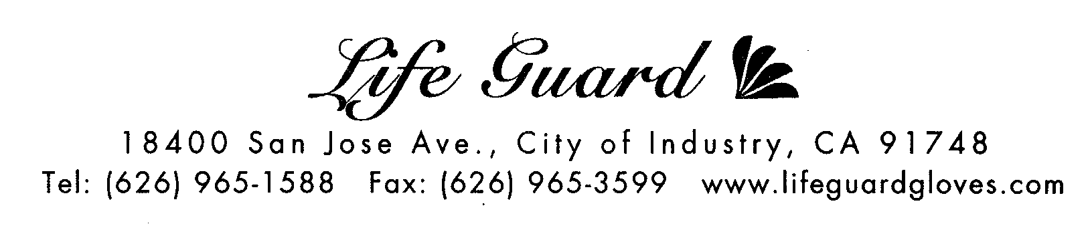

MATERIAL SAFETY DATA SHEET

ITEM NUMBER 2190
BRAND NAME: Sanitex

PRODUCT NAME: VINYL NON-MEDICAL PRE-POWDEREDGLOVES,
TRADE NAME: “SANITEX” VINYL GENERAL-PURPOSE GLOVES
FDA 510K NO: NOT REQUIRED
MATERIAL: POLYVINYLCHLORIDE (PVC)
DONNING POWDER: USP ABSORBABLE DUSTING POWDER
D.O.T RATING: NOT RESTRICTED
SAMPLING PLAN S-4, AQL ABOUT 2.5

Sanitex Gloves are first grade gloves freshly manufactured on the same production line that medical gloves are made but without going through the rigorous FDA medical inspection. We do not use rejects or 2nds. Our gloves are made with ingredients in compliance with 21CFR as accepted by the USDA for use in food processing industry.

SPECIFICATION
SIZE (ITEM #) | Small (2192) | Medium (2193) | Large (2194) | X-Large (2195)
Length (mm) | 230 | 235 | 240 | 240
Width at Palm (mm) | 85±5 | 95±5 | 105±5 | 115±5
Min. Thickness at Palm mm (mil) | 0.08mm (3.1 mil) | 0.08mm (3.1 mil) | 0.08 (3.1 mil) | 0.08 (3.1 mil)
Min. Thickness at Finger mm (mil) | 0.08mm (3.1 mil) | 0.08mm (3.1 mil) | 0.08 (3.1 mil) | 0.08 (3.1 mil)
PROPERTIES
BEFORE AGING
TENSILE STRENGTH | MIN 11 MPa
ULTIMATE ELONGATION | MIN 300%
POWDERED LEVEL (average) | 0.01gram per square dm.
ORIENTATION | Ambidextrous
CUFF | Rounded Bead
COLOR | Natural Clear
CORN STARCH
APPREARENCE | PH | MOISTURE | ASH CONTENT | SEDIMENTATION
White Free Flowing Powder | 10.0 to 10.8 | 12.0% (MAX) | 3.0% (MAX) | 45 to75 ML

FIRE AND EXPLOSION
STABILITY | FLASH POINT | EXTINGUISHING MEDIA | CONDITION TO AVOID | IMCOMPATIBLE MATERIALS
Stable | N/A | Foam ,Water, Carbon dioxide | Extreme Heat | None
PACKING 100 pieces per box, 10 dispenser boxes per case
14 cases/layer, 8 layers high, 112 cases/pallet.
Pallet Dimensions: 45” x 48” x 85” high.
STORAGE Store at room temperature. Keep away from heat.
Avoid direct sunlight and fluorescent light.
CAUTION Components used in making these gloves may cause adverse allergy in some users and
patients. Immediately discontinue use and seek medical assistance if reactions are suspected.
Gloves are not intended for use as a general chemical barrier. Not for medical use.

