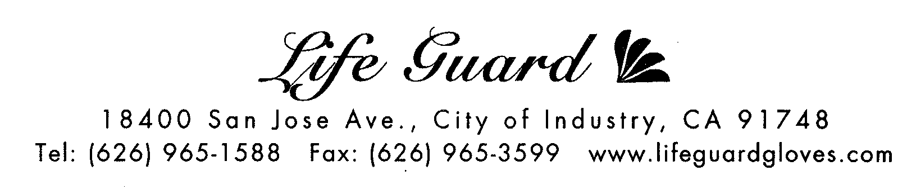

***MATERIAL SAFETY DATA SHEET***

ITEM NUMBER 6390

PRODUCT NAME: NITRILE POLYMER COATED POWDER FREE GLOVES

NON - STERILE

TRADE NAME: “Sanitex”

MATERIAL: 100 % NITRILE -BUTADIENE COMPOUND

FDA 510 (K) NO: Not Required

FDA 2892 NO: Not Required
REGISTRATION NO: 2086535

IATA/IACO HAZARD RATING: NOT RESTRICTED
D.O.T. RATING: NOT RESTRICTED
ASTM STANDARD: ASTM D6319-99
1000cc WATER TIGHT TEST: NOT PERFORM.
SAMPLING PLAN: S-2, ABOUT AQL 2.5

SPECIFICATION
Size / Item # | S / #6392 | M / #6393 | L / #6394 | XL / #6395
Length (mm) / inch | 240 / 9.5” | 240 / 9.5” | 240 / 9.5” | 240 / 9.5”
Width at Palm (mm) | 85±5 | 95±5 | 105±5 | 115±5
Thickness at finger mm (mil) | 0.10 (4 mil) | 0.10 (4 mil) | 0.10 (4 mil) | 0.10 (4 mil)
Thickness at palm mm (mil) | 0.08 (3.5 mil) | 0.08 (3.5 mil) | 0.09 (4 mil) | 0.09 (4 mil)
Thickness at Cuff mm (mil) | 0.075 (3 mil) | 0.075 (3 mil) | 0.075 (3 mil) | 0.075 (3 mil)
PROPERTIES
 | BEFORE AGING | AFTER AGING*
TENSILE STRENGTH | Minimum 21 Mpa | Minimum 19 MPa
ULTIMATE ELONGATION | 700 % | 680 %
*(N.B. Accelerated aging at 70+/-2 degrees centigrade for 166+/-2 hrs.)

Coating Material | Polyurethane Polymer
ORIENTATION | Ambidextrous, Full Textured
CUFF | Round beaded cuff
COLOR | Blue

FIRE AND EXPLOSION
Stability | Flash Point | Extinguishing Media | Conditions to Avoid | Incompatible Material
Stable | N/A | Foam, Water, CO2 | Extreme Heat | None

PACKAGING 100 pieces per box, 10 dispenser boxes per 20-lb case, 100 cases/pallet.

STORAGE Store at room temperature. Keep away from heat.
Avoid direct sunlight and fluorescent light.

CAUTION *Immediately discontinue use if reactions are suspected.
*Not intended for use as a general chemical barrier.
*Safe use of this glove by or on latex sensitive individuals
has not been established.

05/2008

